**Foundation University**

**School of Science and Technology**



**Data Structure**

**Lab Manual 04**

**Submitted by:** Amina Ijaz

**055**

**Submitted to:** Sir Sharjeel

**Department of Engineering Technology**

**LAB TASK**

**Searching and Sorting**

**Question no.1**

**Code:**

#include <iostream>

using namespace std;

int main() {

cout << "=== Antique Inventory Search ===\n";

// Array containing serial numbers of antique pocket watches

int serialNumbers[] = {1021, 1345, 1789, 1900, 2222, 2541, 3009, 3333, 4120};

int size = sizeof(serialNumbers) / sizeof(serialNumbers[0]); // total number of elements

int target;

cout << "Enter the serial number of the vintage pocket watch: ";

cin >> target;

bool found = false; // to track if item is found

int position = -1; // will store index of found item

// Sequential search through the array

for (int i = 0; i < size; i++) {

if (serialNumbers[i] == target) {

found = true;

position = i;

break; // stop searching once found

}

}

// Display result to the user

if (found)

cout << "\nVintage pocket watch found at position: " << position + 1 << endl;

else

cout << "\nSorry, no pocket watch found with serial number " << target << endl;

return 0;

}

**Output:**

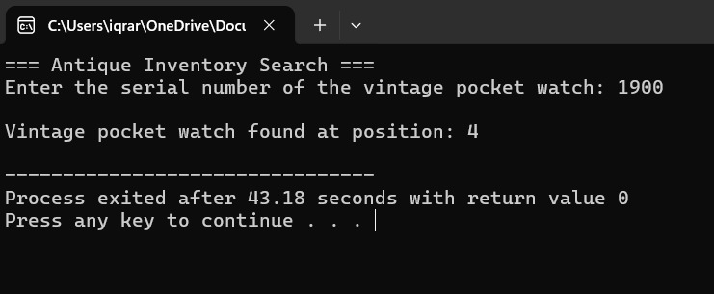

**QUESTION 2**

**Code:**

#include <iostream>

using namespace std;

int main() {

int studentIDs[10] = {1001, 1005, 1010, 1015, 1020, 1025, 1030, 1035, 1040, 1045};

int target;

cout << "Enter student ID to search: ";

cin >> target;

int low = 0, high = 9;

bool found = false

// Binary Search works only on sorted data

while (low <= high) {

int mid = (low + high) / 2;

if (studentIDs[mid] == target) {

cout << "Student found at position " << mid + 1 << endl;

found = true;

break;

}

else if (studentIDs[mid] < target)

low = mid + 1; // Search in right half

else

high = mid - 1; // Search in left half

}

if (!found)

cout << "Student with ID " << target << " not found." << endl;

return 0;

}

**Output:**

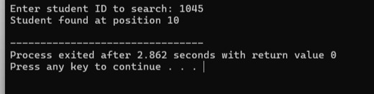

**QUESTION 3**

**Code:**

#include <iostream>

using namespace std;

int main() {

cout << "=== Classroom Score Organizer ===\n";

int scores[15] = {78, 45, 92, 60, 85, 40, 99, 70, 55, 88, 66, 73, 81, 50, 95};

cout << "\nOriginal Scores:\n";

for (int i = 0; i < 15; i++) {

cout << scores[i] << " ";

}

// The algorithm repeatedly compares adjacent elements

// and swaps them if they are in the wrong order.

for (int i = 0; i < 15 - 1; i++) { // outer loop

for (int j = 0; j < 15 - i - 1; j++) { // inner loop

if (scores[j] > scores[j + 1]) {

// Swap if the current score is greater than the next score

int temp = scores[j];

scores[j] = scores[j + 1];

scores[j + 1] = temp;

}

}

}

cout << "\n\nSorted Scores in Ascending Order:\n";

for (int i = 0; i < 15; i++) {

cout << scores[i] << " ";

}

cout << "\n\nScores have been organized from lowest to highest.\n";

return 0;

}

**Output:**

